**Visvesvaraya Technological University**

# Belagavi, Karnataka, 590 014.



## **AICTE Activity Point Programme on**

**“Local Tourism through Innovative Approaches”**

(Non-Credit Activity of 2 Weeks (80-90 hours))

Submitted in partial fulfillment of the requirements for the award of

**Bachelor of Engineering**

**in**

**Computer Science and Engineering**

**Semester III**

**Academic Year 2021-2022**

***Department of Computer Science & Engineering***

|  |  |  |
| --- | --- | --- |
|  | K. L. E. SOCIETY’S**K. L. E. INSTITUTE OF TECHNOLOGY,**Opp. Airport, Gokul, Hubballi-580 030Phone: 0836-2232681 Website: www.kleit.ac.in | **kle-logo** |

## **AICTE Activity Point Programme on**

**“Local Tourism Through Innovative Approaches”**

**List of the sites visited**

1. **MUNDGOD TIBETAN COLONY**
2. **GADEN JANGTSE AND GADEN SHARTSE**
3. **KAGYU MONASTERY**
4. **SAKYA MONASTERY**
5. **RATO MONASTERY**

**Group Members Visited the Site**

|  |  |  |
| --- | --- | --- |
| **SL NO** | **NAME** | **USN** |
| **1** | **RAMYA.BENNI** | **2KE20CS070** |
| **2** | **PRATIKSHA.GUDARAD** | **2KE20CS060** |
| **3** | **RAMYA.KULKARNI** | **2KE20CS069** |
| **4** | **PAVANKUMAR.BAMMANAL** | **2KE20CS124** |
|  |  |  |

AIM

SURVEY OF THE MUNDGOD TIBETAN COLONY

HISTORY

**The Tibetan Colony in Tattihalli village near Mundgod Taluk in Uttara Kannada district (or North Canara) is one among the six Tibetan settlements in the state of Karnataka. Doeguling Tibetan Settlement, as it is officially known, was established in 1966. The settlement is divided into 11 villages which covers an area of 4000 acres of land. Two villages – Gaden and Drepung – among the eleven are monastic villages. “It is the largest Tibetan refugee settlement in the world inhabited by 17,000 Tibetans and has a cluster of seven monasteries, a Tibetan Medical and Astro Institute, 20 schools, two homes for the elderly and a cooperative society”**

**Monasteries of Doeguling Tibetan Settlement**

**The mammoth sized monasteries in Mundgod is a visual delight for all who visit the settlement. Beyond its aesthetic appeal, the monasteries preserve centuries old tradition, knowledge and religious texts of Tibetan Buddhism. There are seven main monasteries in Doeguling Tibetan Settlement which are,**

* **Gaden Jangtse and Gaden Shartse**
* **Drepung Loseling and Drepung Gomang**
* **Kagyu Monastery**
* **Nyingma Monastery**
* **Sakya Monastery**
* **Jangchub Choeling Nunnery**
* **Rato Monastery**

**Gaden, Drepung and Sera monasteries are considered as the three monastic seats of Gelugpa Sect. Gaden and Drepung Monasteries are in Doeguling and Sera Monastery is located in Lugsung Samdupling Settlement in Bylakuppe. All the major four sects within Tibetan Buddhism – Gelug, Sakya, Nyingma and Kagyu – have their monasteries in the Doeguling settlemen**

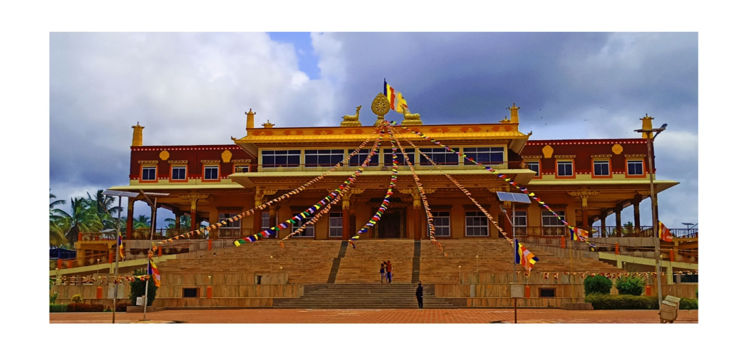

Gaden Jangtse Monastery

**Tsongkhapa Lobsang Drakpa, the founder of Gelugpa sect, founded Gaden Monastery in 1409 at Lhasa. “When the last surviving members of Gaden Monastic University from Tibet arrived in India as refugees, they felt the preservation of Tibetan culture and religion to be a serious challenge for the Tibetans if they are to retain their cultural identity as a people…In spite of many harsh realities of life imposed upon them, they re-established Gaden in South India in 1971, and were able to revive the general pattern of studies that once existed in Tibet” (Snow Lion 1988). Tashi Pelden and Sakya Yeshe, Tsongkhapa’s disciples, founded Drepung and Sera Monasteries respectively in Central Tibet.**

**“During the lifetime of Second Gaden Tripa (highest living Guru in the Gelug sect of Tibetan Buddhism) – Great Khedup Je, four groups of sangha communities mushroomed in Gaden Monastery. These four groups were later merged into two groups, which were then named two colleges – *Shartse* (under the leadership of Mahathera Rinchen Gyaltsen), and *Jangtse* (under the leadership of Horton Namkha Palzang)”**

Drepung Loseling Monastery 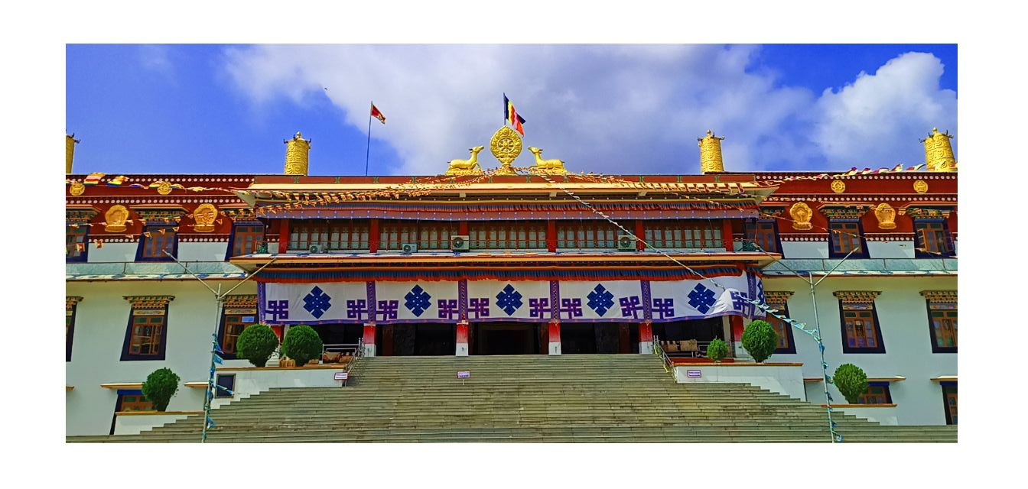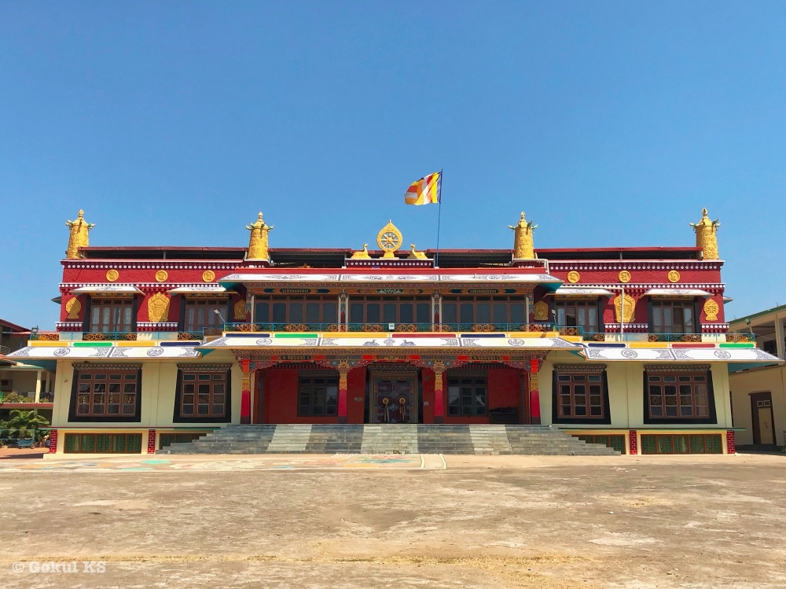

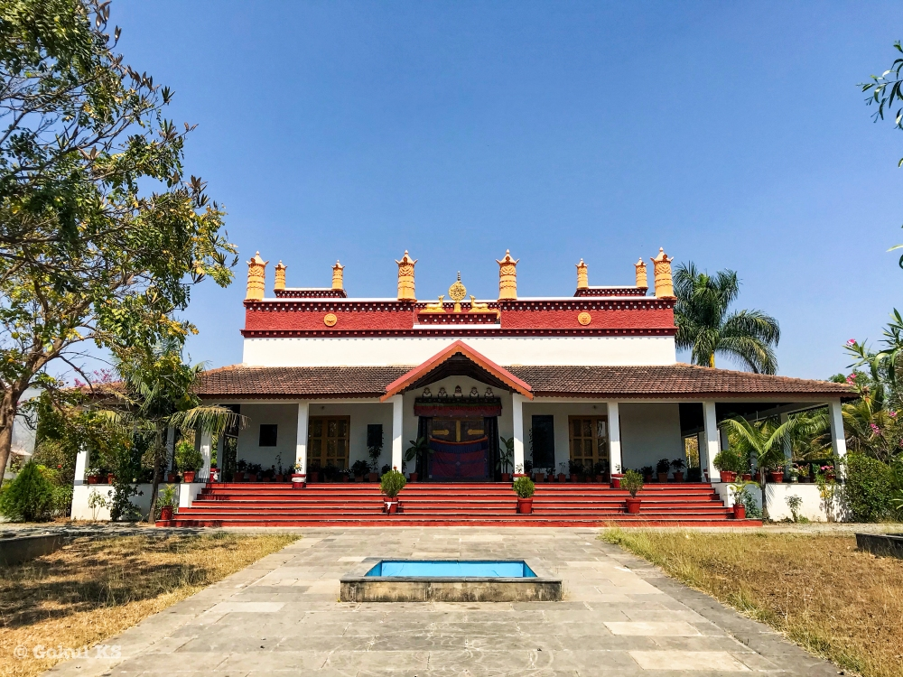

**The Rato Monastery was established in 14th century in Tibet to preserve Buddhist teachings and it was then called “Tiger Nest” by the 5th Dalai Lama. In 1983, Rato Dratsang was re-established in exile at Mundgod. It is an eco-friendly monastery and the architecture of the Dratsang is distinct from other monasteries in Mundgod. “As part of a capital fund drive to construct the new temple and monastic campus for Rato Dratsang, a traveling exhibition of photographs by Geshe Nicholas Vreeland has raised USD 400,000 (Rato 2011). The re-construction was completed in 2011. Geshe Nicholas Vreeland, also known as Monk with a Camera, is the Abbot of Rato Dratsang and he became the first non-Tibetan origin Abbot who was appointed in 2012**. ***Monk with a Camera*, the 2013 documentary directed by Guido Santi and Tina Mascara was based on the life of Nicky Vreeland. The monastery is owned by Tibetan Government and His Holiness Dalai Lama appoints the Abbot of the monastery**.

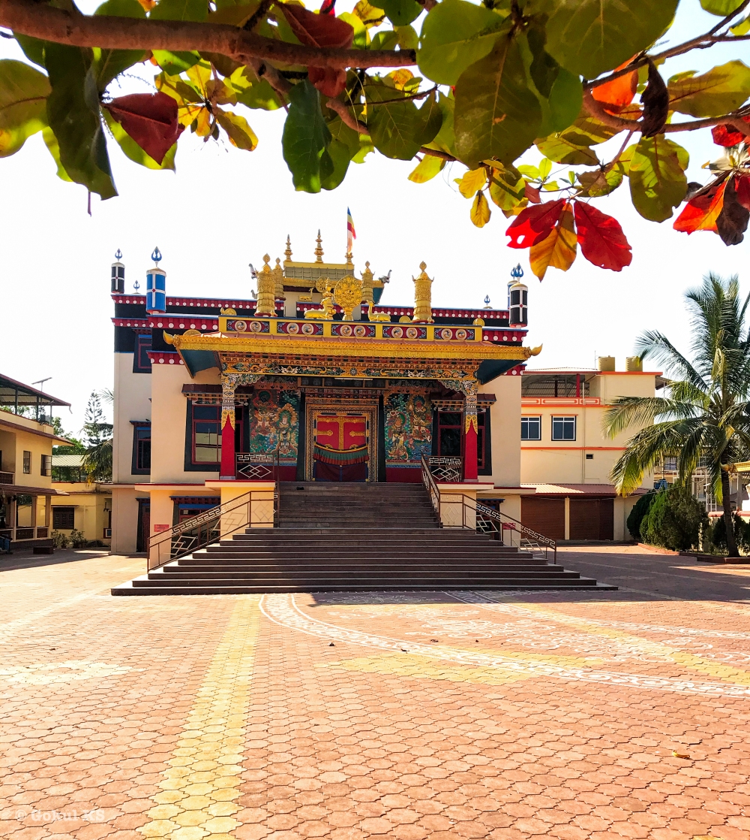 Nyingma Monastery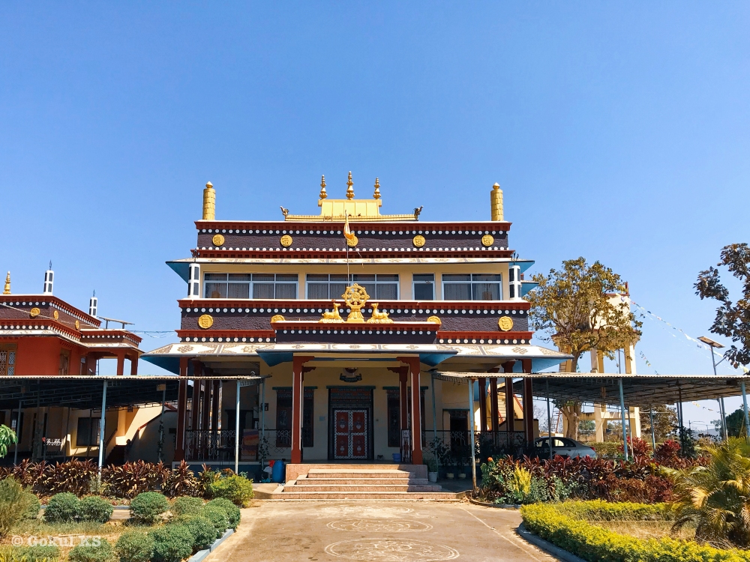Kagyu Monastery

**The only nunnery in the Doeguling Settlement is Jangchub Choeling Nunnery which was founded in 1987. The vision was to construct an educational institution for Tibetan women of all ages to study the Buddhist religion and scriptures. “In 1986, a small prayer hall was built with the help of the Tibetan Government in Exile. Disused houses belonging to the neighboring nursing home were renovated with the support of the German Aids to Tibetans and the Tibetan Centre Hamburg in Germany. A year later in 1987, the first 18 nuns from the local Tibetan settlement in Mundgod moved into the nunnery” (JCN 2018).**

**Besides these major monasteries, there are several other monasteries, personal temples, colleges, institutes and other religious centers of education in Mundgod. The most of them are located in the two monastic villages of Drepung and Gaden.**

**Doeguling Tibetan Settlement**

**Doeguling is the second Tibetan settlement established in the state of Karnataka and “unlike the earlier Tibetan settlements elsewhere in India which were mainly supported by the Indian government, foreign voluntary agencies took up the maximum responsibility in establishing this settlement” (Choedup 2015: 90). Doeguling is the first settlement in South India to sign Lease Agreement under Tibetan Rehabilitation Policy 2014.**

**“According to the statistics (1971 Mundgod Taluk Census) nearly five times the cultivable area is still under forest. Thus the initial reason for the establishment of the Tibetan colony in Mundgod was to develop the area and bring more land under cultivation. This type of development was urgently needed since the natural resource was going waste. The land in the region is fairly fertile and the rain is quite moderate. It was difficult to settle Indians there because of the popular opinion that Mundgod and other surrounding areas were places of malaria. Thus the establishment of Tibetan settlement at Mundgod was intended to serve as an incentive to further settlement.**

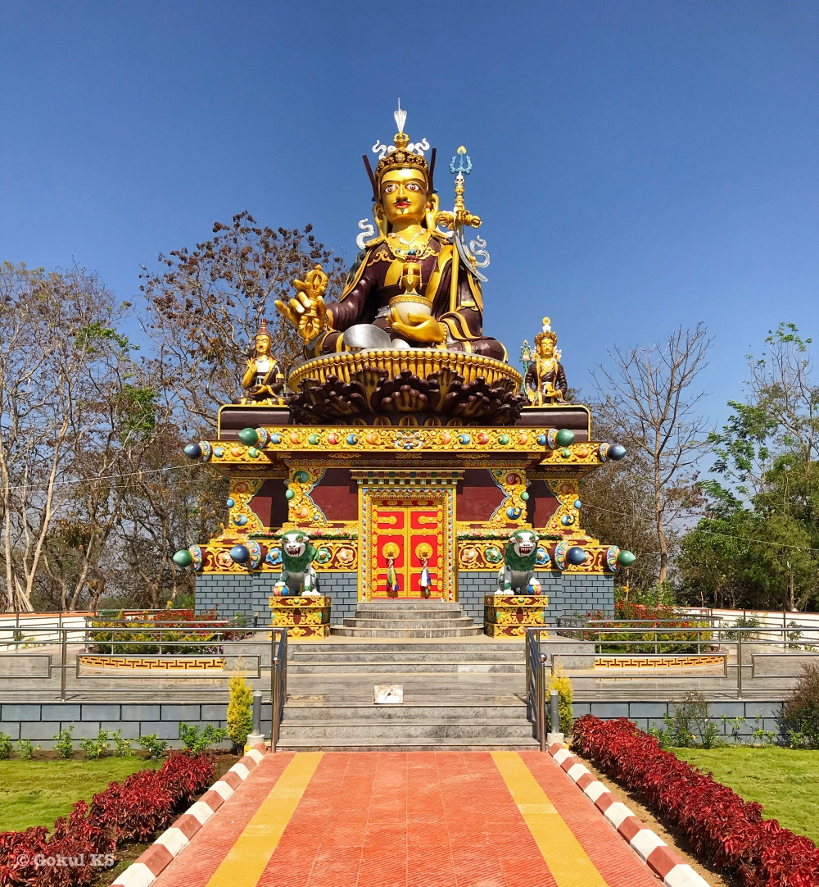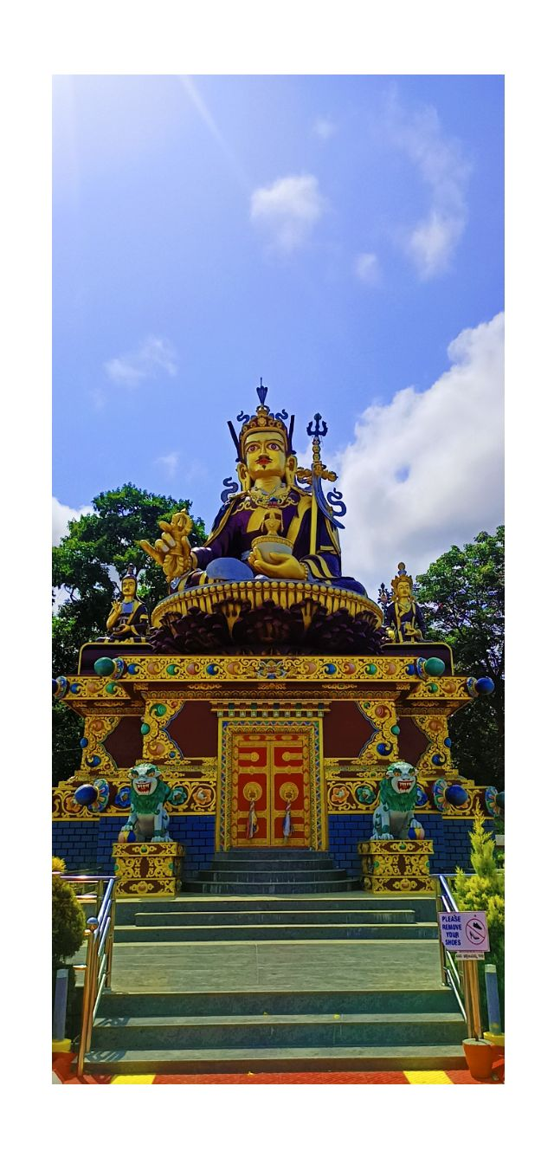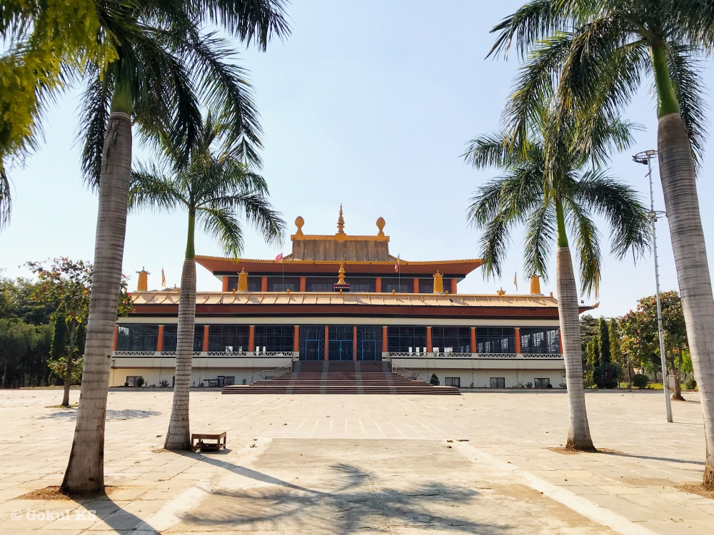

**“The majority of the original settlers were from the road construction camps in Dharamsala, Kulu, Ladakh, Simla, Dalhousie, and temporary refugee camps in UP. A small group of Tibetans were also sent from detention centers in Rajasthan and other places (He notes, “these were mainly Tibetan refugees who arrived as individuals after the 1962 Sino-Indian War and were detained by the Indian intelligence agencies to verify their antecedents. Most of them were not allowed to leave the settlement for travel within India for many years”). The Tibetans refugees were sent in batches by road and railway under escorts appointed by the Indian authorities. The first two batches of about 300 people arrived in November 1966 from road construction camps near Dharamsala. They were sent under escorts through Pathankot railway station to Hubli, then brought in transport trucks to Mundgod, and housed in tents. Later, bamboo huts, and mud houses were built as a temporary measure while the settlers cleared and burned the trees… the Tibetans also worked on making roads in the newly cleared forestland”**

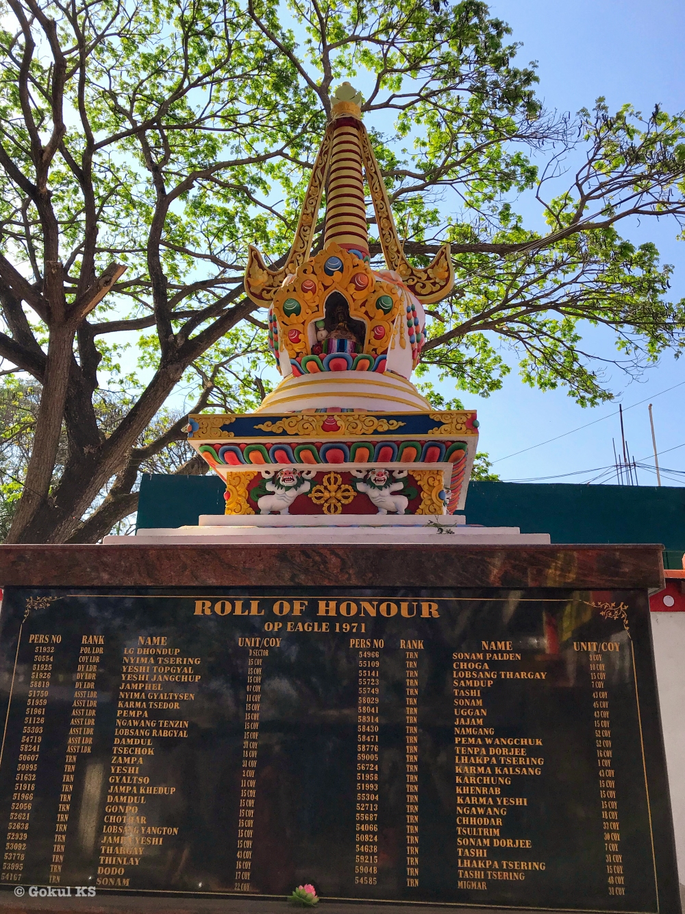

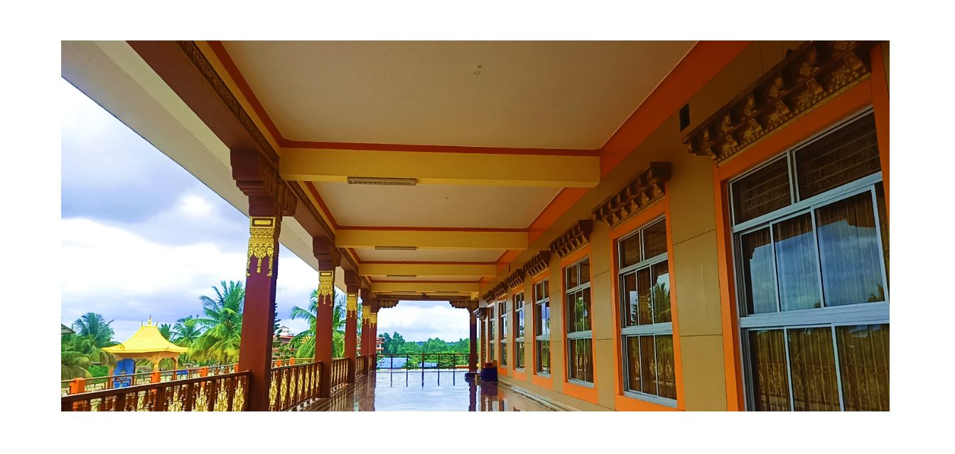

**One of the major crisis faced by the Tibetans in Mundgod is the scarcity of water. Due to the lack of irrigation facilities, they depend on annual rainfall for their livelihood and agricultural purposes. “To tackle the water crisis, Reimagining Doeguling (RDTS) and the Geluk International Foundation successfully implemented a rainwater harvesting project in their settlement which recharged their bore wells” (Das 2019). Arti Das quotes Tenzin Thakpo, Chairman of the Water Committee of RDTS, “The Mundgod taluk receives 900 mm of rainfall in four months during the monsoon but rainfall is declining every year.” He shared concerns regarding water crisis in the future saying, “According to a report by the NITI Aayog, Karnataka is the second state after Rajasthan where water levels are depleting at an alarming scale.**

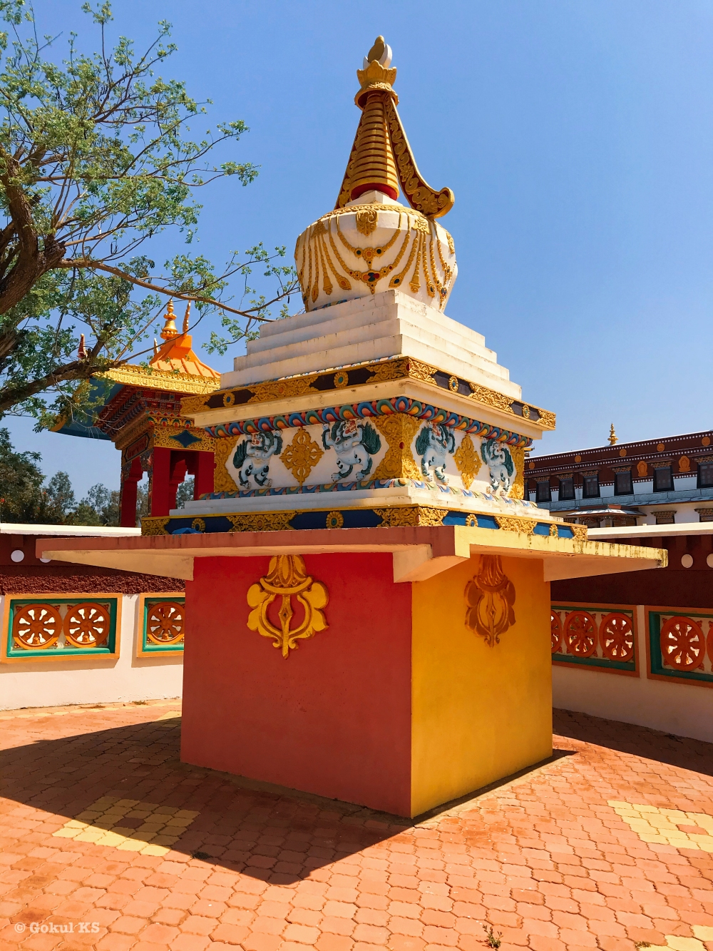

Entrance of Drepung Loseling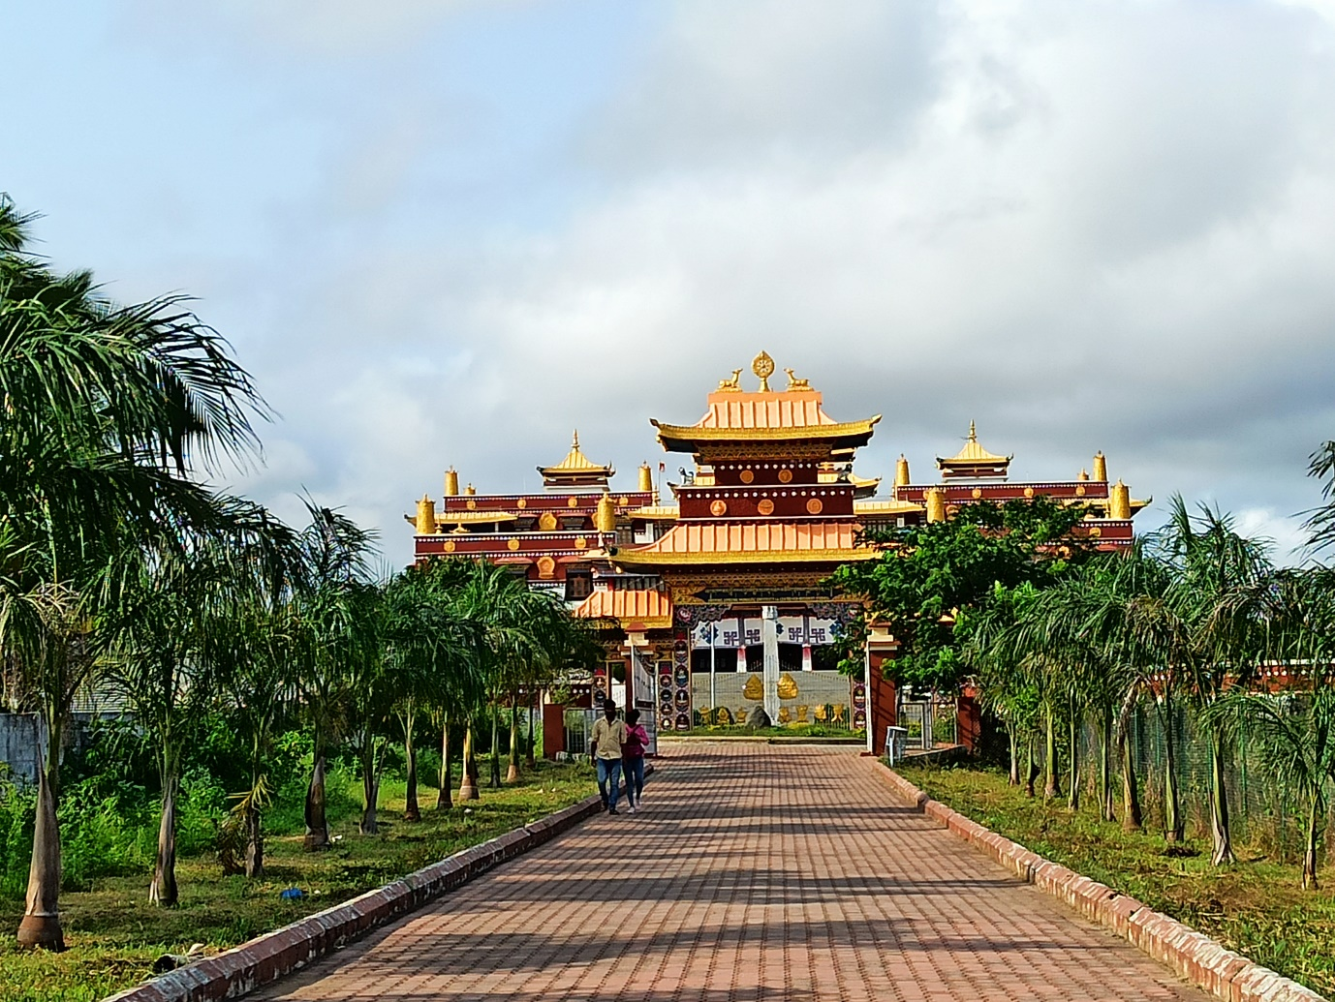

**Drepung loseling**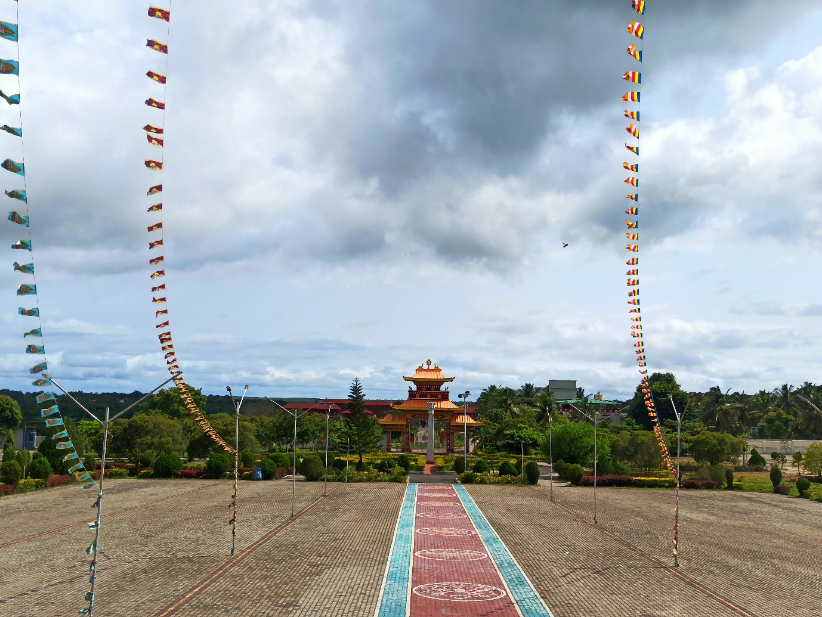

Kalachakra Stupa near Gaden Jangtse 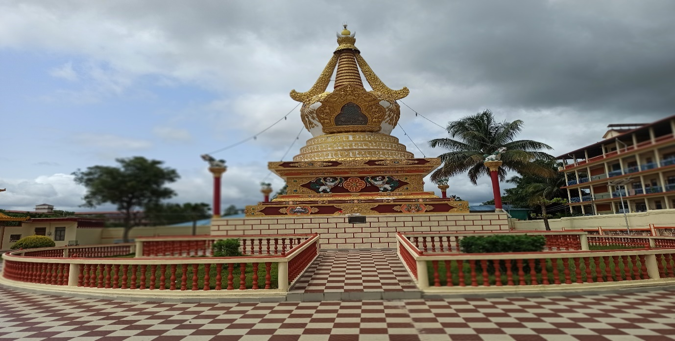 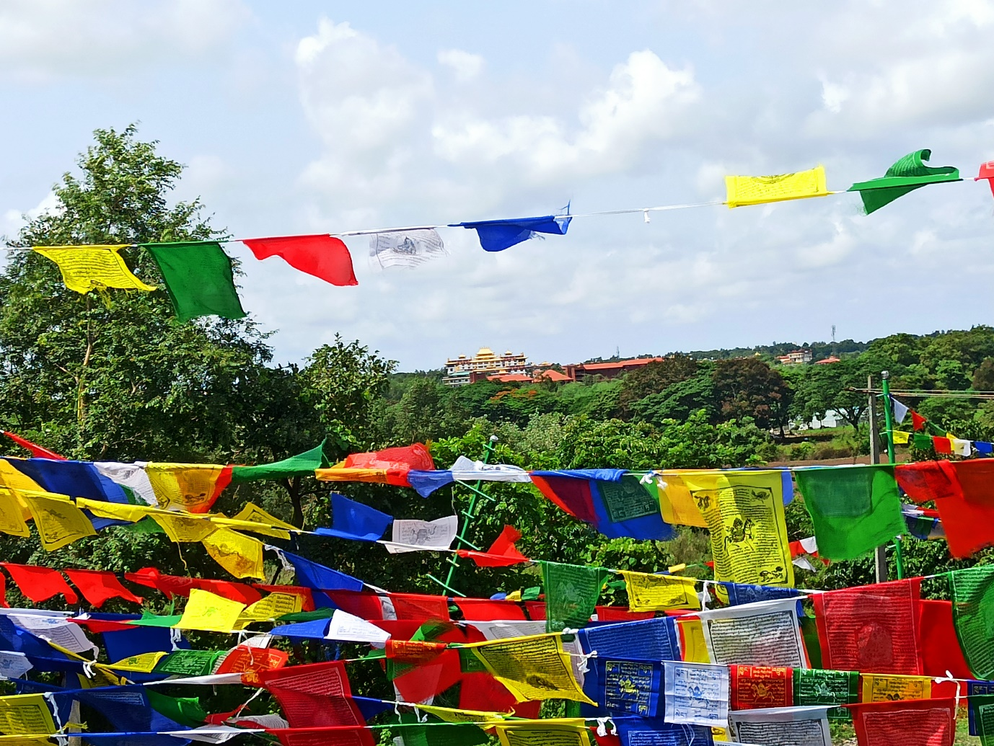**Tibetan Prayer Flags**

***“*Many older Tibetans remember the early days as very difficult period. At the same time, they say people were happy go lucky (*snang ba skyi bo*) and most believed that they would return to Tibet after a few years. They remember nostalgically the communitarian spirit of the early years; after a day of hard manual work, bonfires would be made around and everyone would participate in folk dancing (*sgor gzhas*) and singing late into the night”**

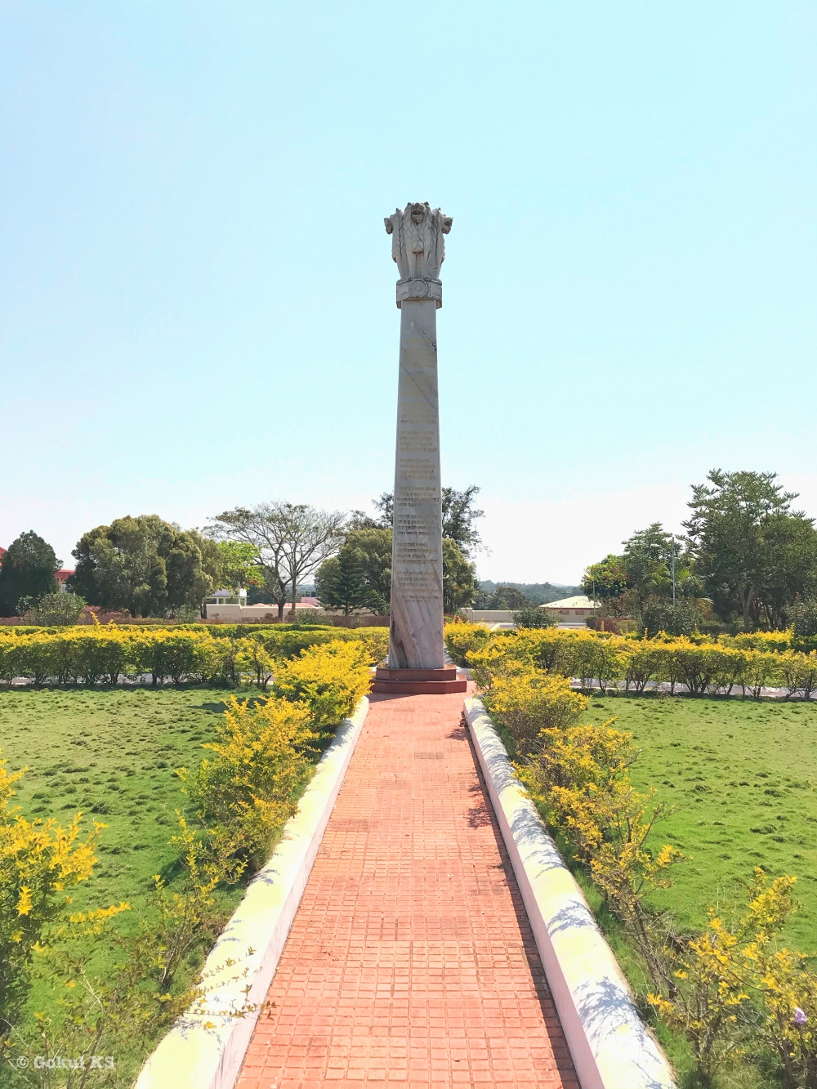**Pillar erected in front of Drepung Loseling**

**REFFERENCE:-**

**https://en.wikipedia.org/wiki/Drepung_Monastery**

**https://www.losellingmonastery.org/english/**

>VISIT TO THE SITE